**COM427 – Week 10 Practical**

**MySQL**

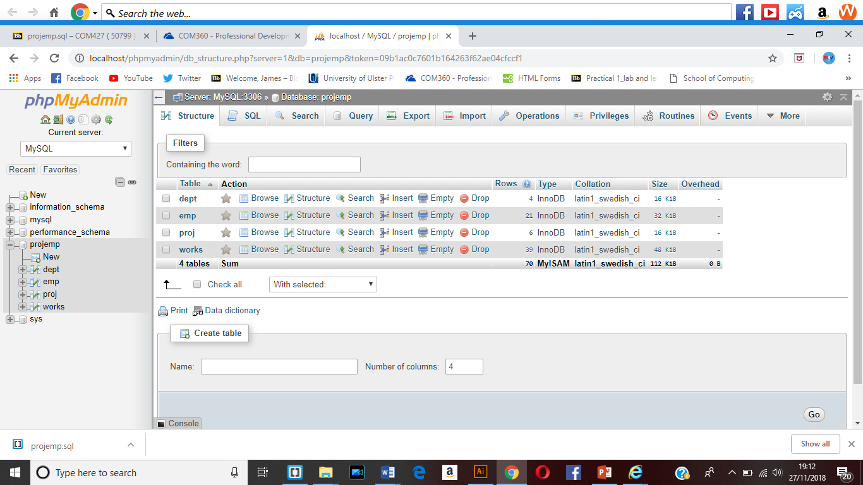

Created the database through the new database information and then added each table through the SQL create command.

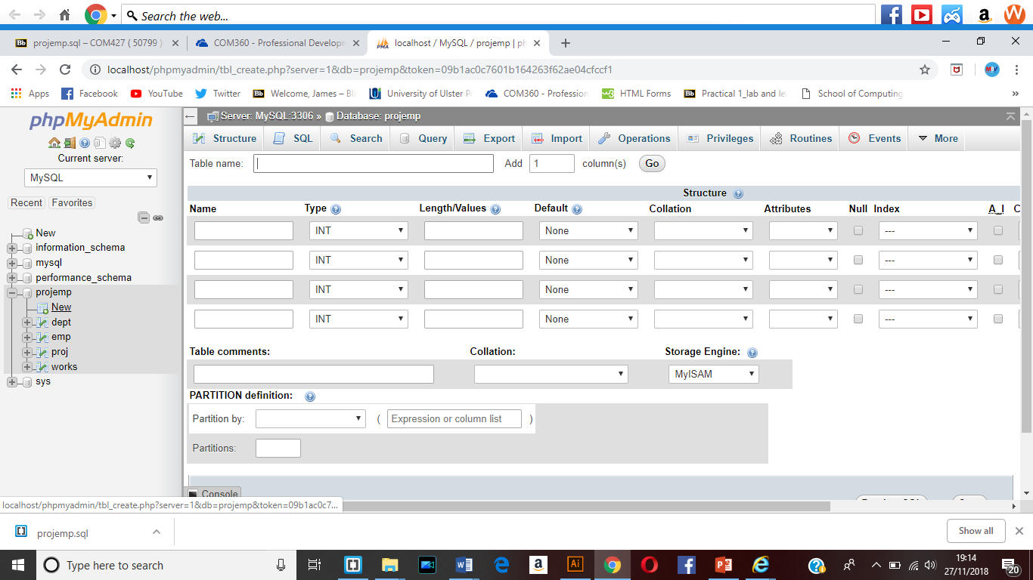

Creating a new table using the predefined function new at the side. This meant that I was able to create a new table with a name and element names.

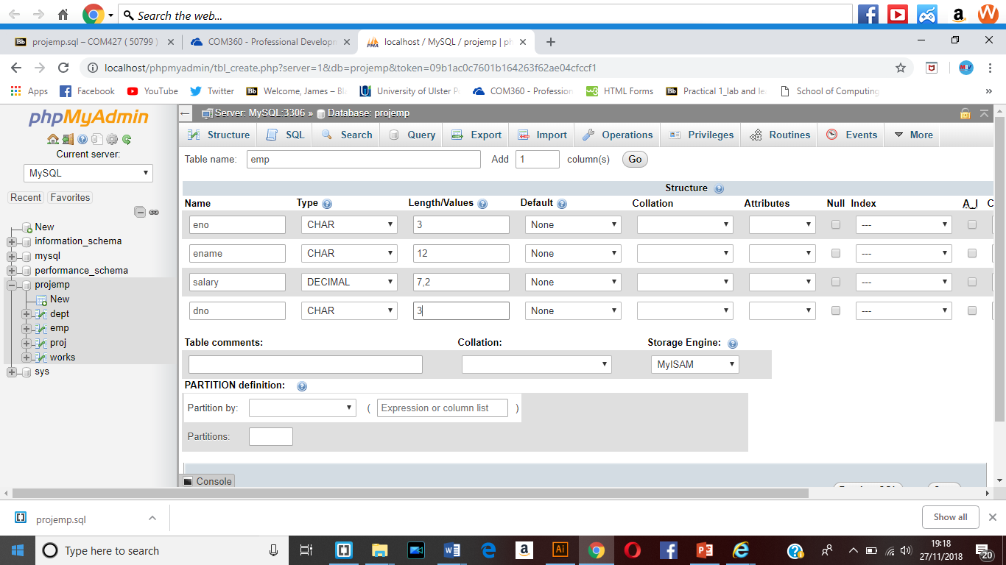

This meant that the information could be entered into the table that was part of the database.

This is one method that would allow for the creation of the tables within the database.

Then the save button was clicked so that this could be created.

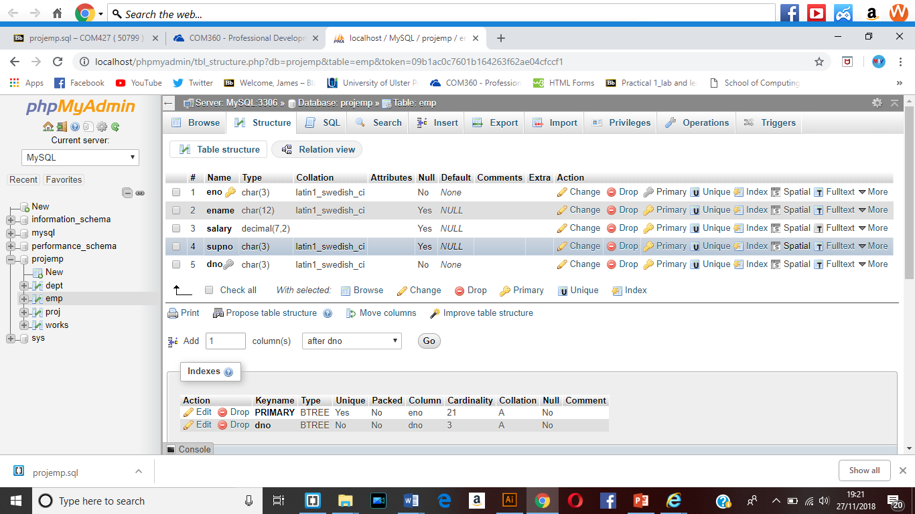

I was also able to look at the structure of the table that had been created which meant that the table structure could be edited within phpMyAdmin.

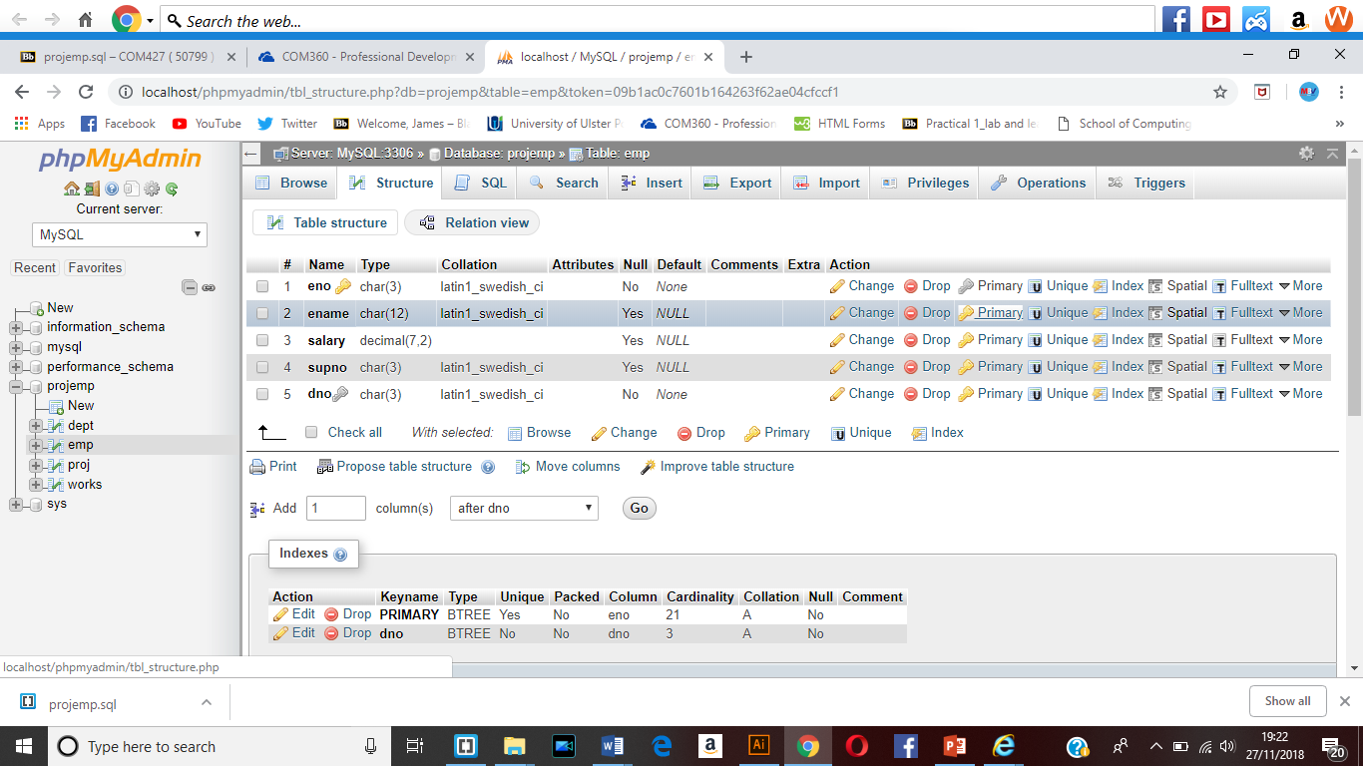

I also looked at how the primary key could be set within the design structure through the click of the primary option with the key icon.

This was used for the unique identifier within the design.

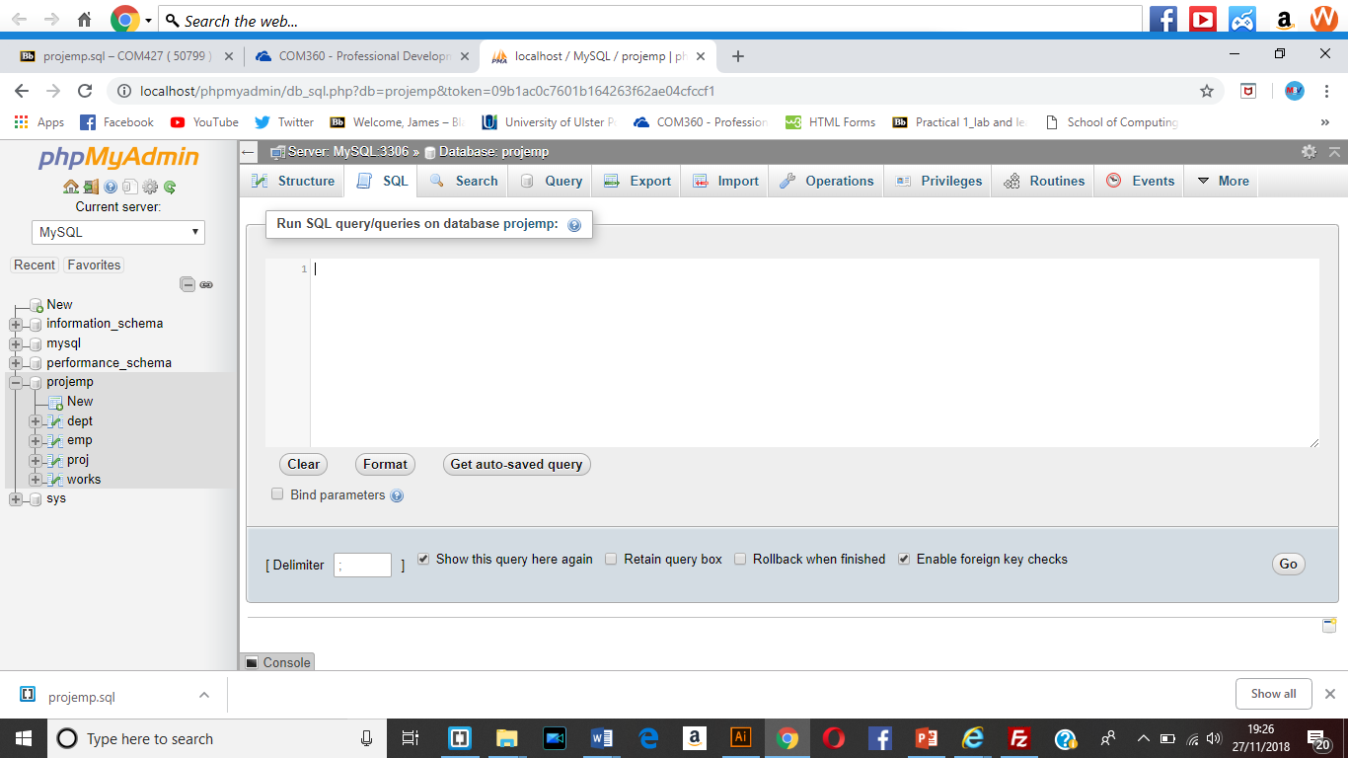

During week 10 I also looked at the SQL set up which would mean that the table could be created through the use of hand writing in the code.

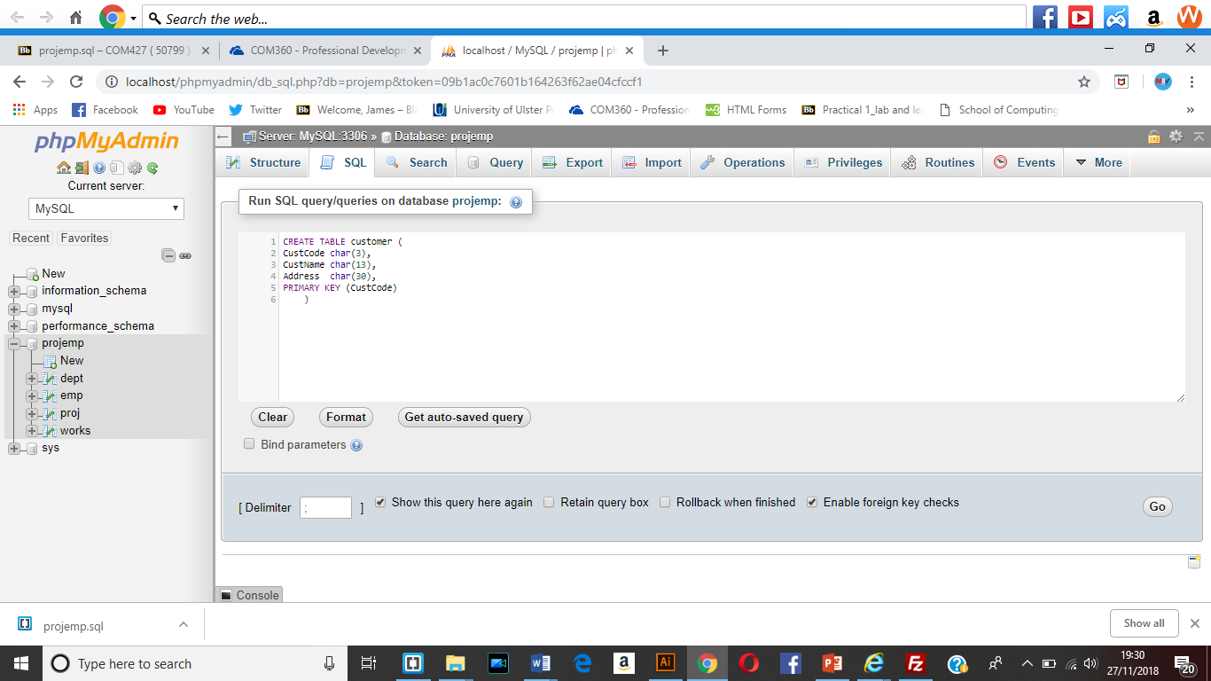

This means that I have looked at how to be able to create tables within the DataBase through the use of the SQL query creation window. This allows me to create a customer table with elements CustCode, CustName and Address added to it with the define type and length and the primary key applied to them.

Then the go button was clicked.

CREATE TABLE customer (

CustCode char(3),

CustName char(13),

Address char(30),

PRIMARY KEY (CustCode)

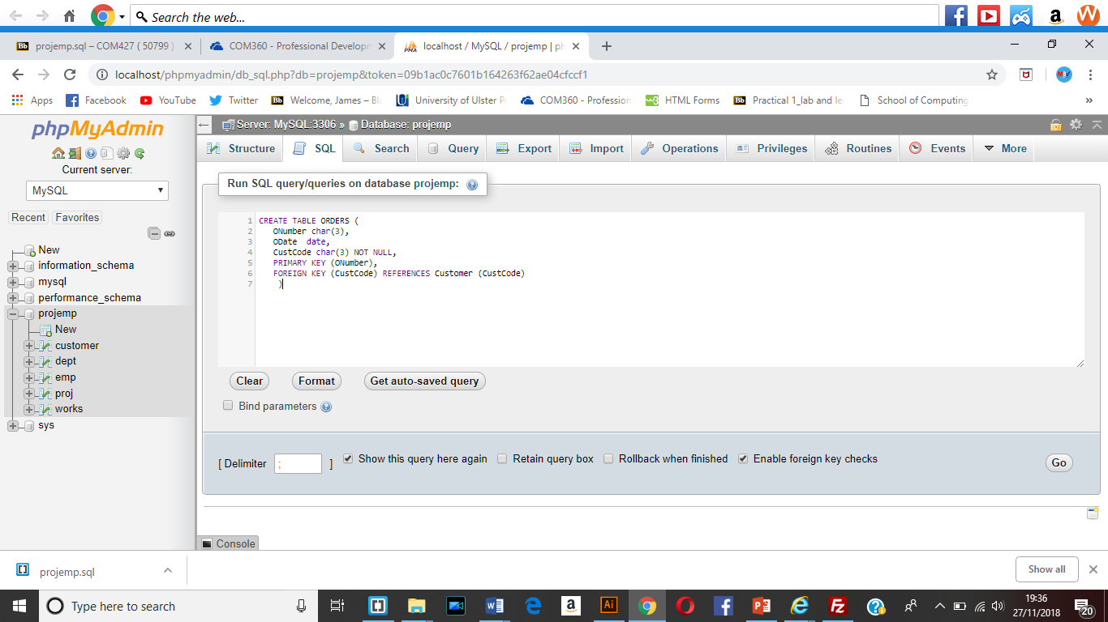 )

This can be used to create primary keys within the tables and also foreign keys which mean that it contains an element which references another tables element.

CREATE TABLE ITEM (

ItemCode char(3),

ItemName char(12),

UnitCost int,

PRIMARY KEY(ItemCode)

)

The SQL window was used to create a range of tables.

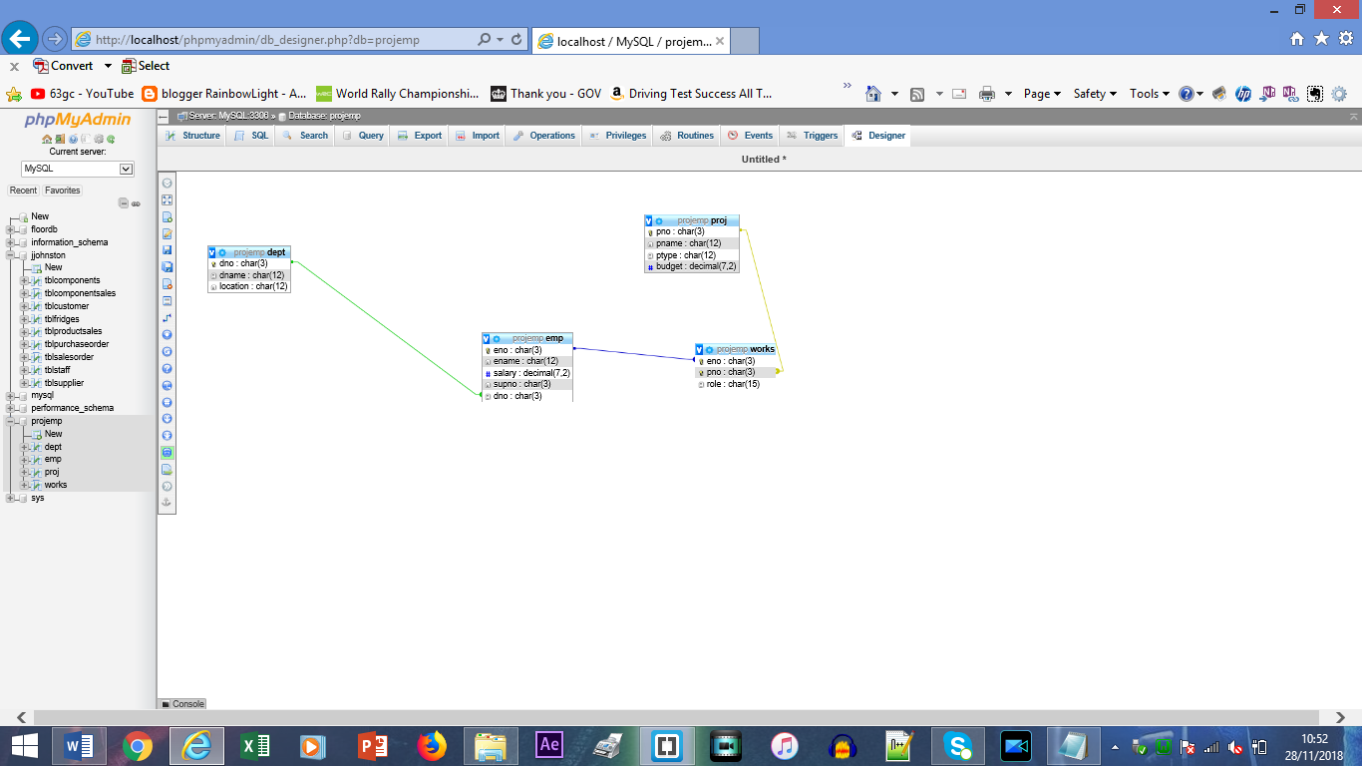

Then when the tables had been created I was able to make use of the designer so that I could see the relational set up within the design. This meant that I was able to see how each of the tables relate to each other through the lines that have been created which is the relational lines.

So this meant that I was able to see how the different tables can be created to include a relationship.

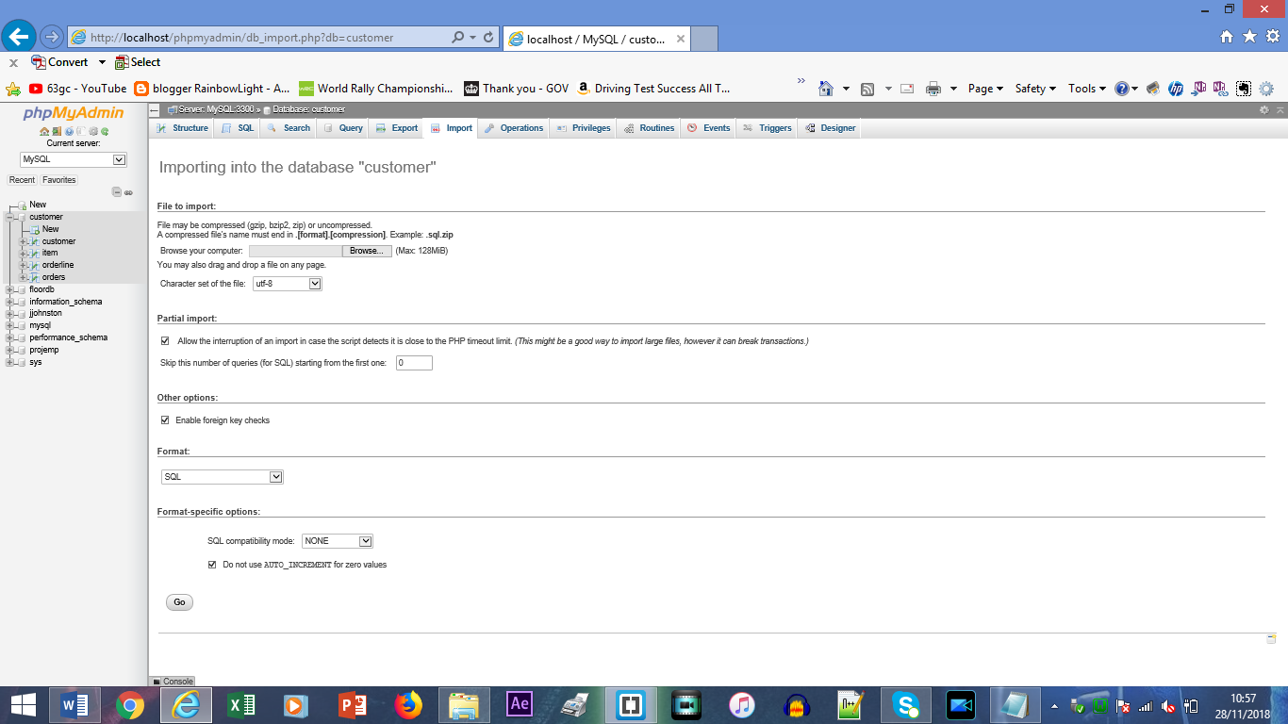

I was also able to familiarise myself with how to import a file into phpMyAdmin. This meant that I was able to see how it is possible to import a database that had been previously created into this system. This also means that it would mean that you would not need to manually create the database.

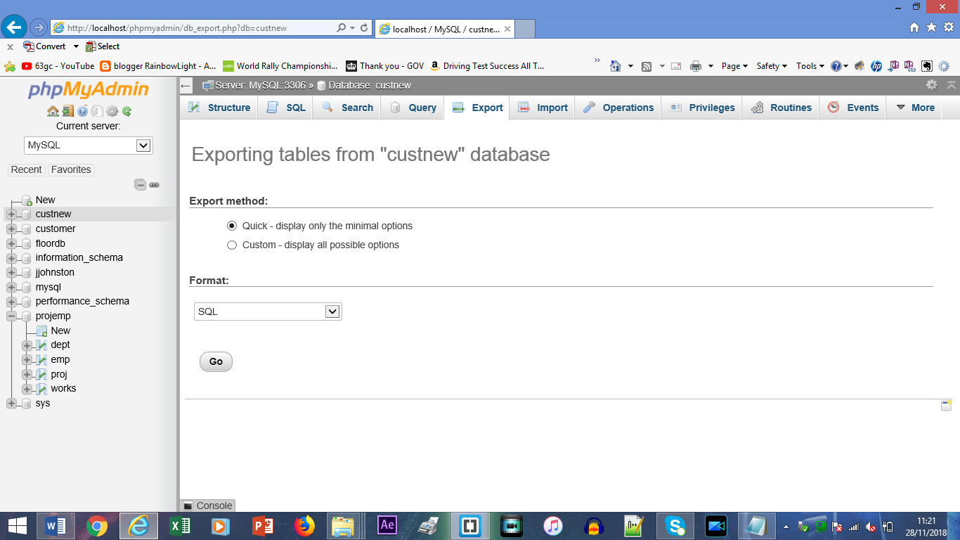

I was also able to look at how it is possible to make use of the export window to enable me to export out the database that has been created. This means that in the future I would be able to import the file into phpMyAdmin again within the design.

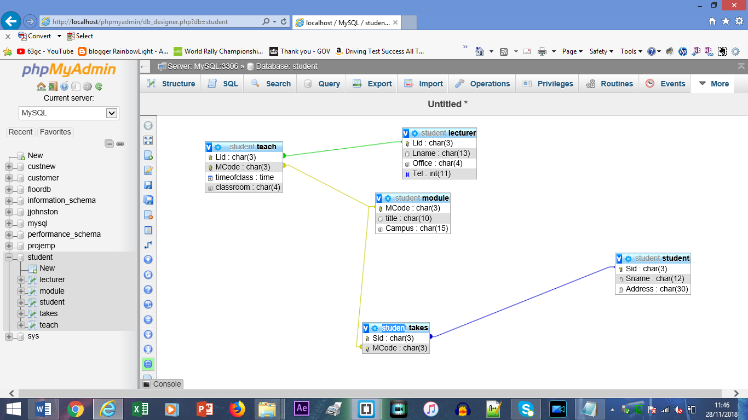

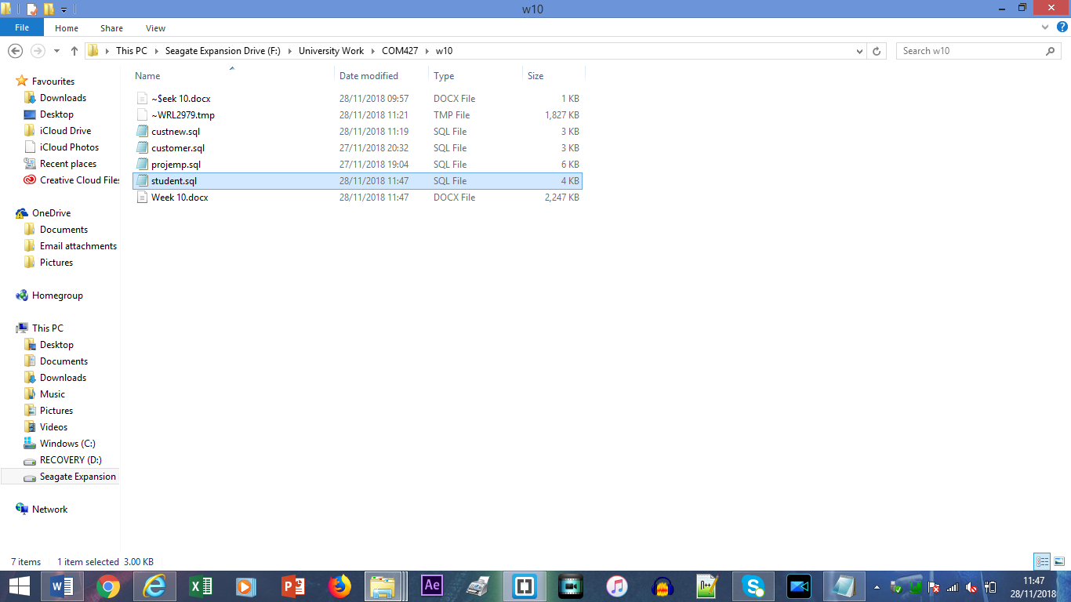I was also able to learn this week as well as creating the data for the tables which would form the database I was able to connect the tables through the primaty and foreign keys so that the tables would show how they link when you go to the designer view. This means that the content of the database could be updated easily.

This file shows the different sql files which meant that the databases that I had created have been exported so that they could be resubmitted to php myAdmin at a different style which meant that the databases can be transported easily between the different computers that may be used.

So this means that during week 10 I was able to learn and understand how to make use of the MySql database through the use of phpMyAdmin.